VE/Rotary Injection Pump – Replacing Top & Middle Seals

Tools Needed
- Laptop
- VAG-COM cable
- Special MetalNerd bit to remove the injection pump's "security bolt"
- T10 Torx bit (if removing the fuel temp sensor)
- T25 Torx bit (to remove the bracket that holds the fuel pump harness)
- T30 Torx bit (to remove the regular bolts on the IP cover)
- 2 - 17 mm open ended wrenchs (for the banjo bolt)
- small screwdriver
- small ball-peen hammer
- block o' wood

Parts
- Bosch Seal and Gasket Rebuild kit
OR
- Top and Middle Seals
- Fuel Temp Sensor (if you want to go ahead and replace it while you're in there)

Procedures
- Note Injection Quantity (IQ) before disassembling pump
  - Turn on the car.
  - NOTE: It has been suggested that "IQ values ought to be done both at 'cold-start' conditions AND at stabilized running conditions". To achieve stabilized running conditions would require approximately 10-15 min of regular driving at this step.
  - Make sure all major electrical consumers (head lights, radio, A/C, etc.) are turned off, since they can effect the IQ.
  - Connect a VAG-COM cable to the OBD2 connector.
  - Open the VAG-COM software on the laptop.
  - Select Control Module > Engine > Measuring Blocks > Block 00
  - Note the IQ (usually between 3.0-5.5 mg/stroke). Assuming there are no drivability issues with the vehicle, you will want to reset the IQ close to this number using the hammer mod, after putting the pump back together. If there are drivability issues with the car that can be addressed by changing the IQ, then you will want to set the IQ to a higher or lower reading than this when doing the hammer mod below.
- Place rags in front of (between pump and alternator) and behind the injection pump (between the pump and the engine) to collect any diesel that spills out during removal of the top cover and housing.
- Mark the position of the Quantity Adjuster housing on the lower pump body.
  - Using a punch or scribe place one set of marks (one mark on the Quantity Adjuster housing lined up with one mark on the lower pump body) on the front of the pump to the left of the black box the injection pump wiring harness attaches to.
  - Make another set of marks to the right of the black box. These marks will be used to line the cover back up after replacing the middle seal.
  - NOTE: Failure to carefully re-align the marks when putting the pump back together could result in a run-away engine.
  - NOTE 2: Note the angle at which you are viewing the marks and make sure you assume the same angle when lining up the QA housing below.
- Disconnect the Injection Pump wiring harness.
  - Remove the bolt and bracket that holds the Injection Pump wiring harness (T25 torx bit).
  - Disconnect the Injection Pump wiring harness from the rounded connection that leads to the main engine harness.
- Remove the banjo bolt on the right side of the pump that holds the fuel return line.
- NOTE: Step 4 and 5 are necessary to allow unhindered removal of the injection pump top cover and the QA housing.
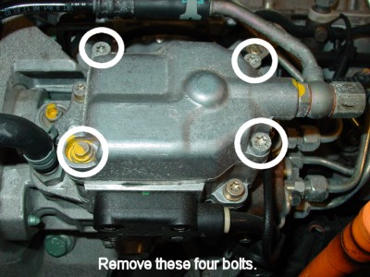
- Remove the Top cover.
  - Loosen the 3 Torx bolts (T30) holding the top cover.
  - Loosen the special bolt located in the left front corner of the top cover. The special bit for removing this bolt can be purchased from metalnerd
  - Lift up the top cover.
- Replace the Top seal.
  - Using a small screwdriver, pry out the old seal from the groove in the top cover.
  - Clean off the bottom of the top cover.
  - Carefully insert the new seal, being sure to line up the little rabbit ear tabs.
- If you are replacing the Fuel Temp Sensor at this time.
  - Remove the 2 Torx screws (T10) holding in the old sensor.
  - Lift out the old sensor, paying attention to how the sensor is seated. The wells on either side of the screw holes in the sensor are asymmetrical. The deeper wells go on the bottom.
  - Seat the new sensor in the injection pump.
  - Replace the 2 Torx screws (T10).
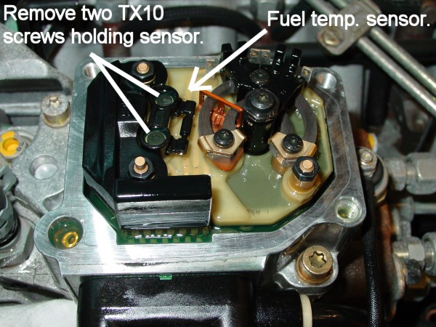
- Reseat the top cover.
  - Clean off the flat surface on the Quantity Adjuster housing where the top cover sits so it will seal tightly.
  - With the new seal firmly seated in the base of the top cover, replace the cover and loosely screw in the 3 regular bolts holding it on (the security bolt needs to remain loose so that the QA housing can be removed next.
- Remove the Quantity Adjuster housing.
  - Remove the 3 additional Torx bolts (T30) holding the Quantity Adjuster housing to the lower pump body. NOTE: You will also need to loosen the "security bolt" using the special tool, if you tightened it when replacing the top cover.
  - You can now lift up the entire Quantity Adjuster housing off the lower pump body.
  - NOTE: There is a small dowel pin (labeled "peg" in the pictures) sticking out of the bottom of the Quantity Adjuster housing. The dowel pin must seat into a hole in a ring located on the right, inside the injector pump body. This ring has a tendency to rotate once the Quantity Adjuster housing is lifted off so that the hole is no longer pointing straight up, so pay attention to this. You may need to use your finger to rotate the ring some to point the hole up again before reseating the Quantity Adjuster housing.
- Replace the middle seal.
  - Using a small screw driver, pry out the old seal from the groove on the bottom of the Quantity Adjuster housing.
  - Clean off the bottom of the Quantity Adjuster housing.
  - Carefully insert the new seal, being sure to line up the little rabbit ear tabs.
- Reseat the Quantity Adjuster housing.
  - Carefully lower the Quantity Adjuster housing back down onto the lower pump body, being sure to insert the peg into the hole in the ring. You probably won’t be able to fully seat the Quantity Adjuster housing, if the peg isn’t seated correctly, but be careful since you won’t be able to see what you’re doing.
  - Once the Quantity Adjuster housing is sitting on the lower pump body line up the scribe marks.
  - Tighten the bolts holding the Quantity Adjuster housing in place and then back them off about 1 turn each (so that the Quantity Adjuster housing can be moved slightly when using the hammer mod below – to adjust IQ).
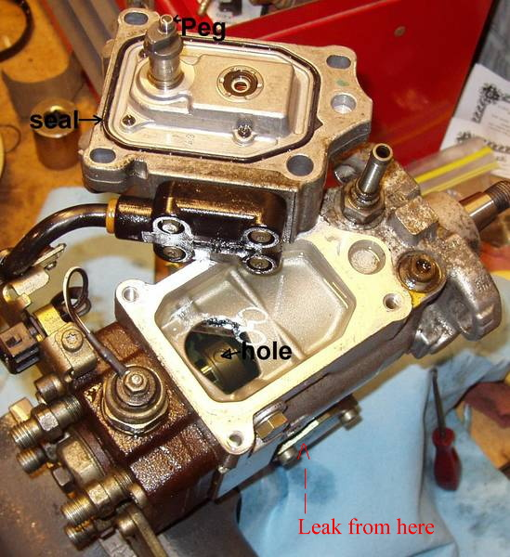
- Start up car
  - It may take a few seconds of cranking for the car to fire, because of the air introduced by opening up the pump. Be careful not to burn up your starter.
  - Please note that if the Quantity Adjuster housing is not lined up exactly as before there is a chance for the engine to run away. Be prepared to shut off the engine immediately, if it revs up on its own after starting.
- Set the Injection Quantity (IQ) using the hammer mod.
  - As when checking the baseline IQ, make sure all major electrical consumers are turned off.
  - NOTE: If you will be using the IQ value for the "stabilized running conditions", drive the car for 10-15 min to warm it up.
  - Connect a VAG-COM cable to the OBD2 connector.
  - Open the VAG-COM software on the laptop.
  - Select Control Module > Engine > Measuring Blocks > Block 00
  - Place a small block of wood against the the injection pump and lightly tap the wood with a hammer to move the Quantity Adjuster housing. As the Quantity Adjuster housing moves the displayed injection quantity will change. Adjust the IQ until it is within an acceptable range.
  - NOTE: Tapping the Quantity Adjuster housing to the right will increase the IQ and tapping the Quantity Adjuster housing to the left will decrease the IQ.
- Additional things to check
  - There is a "three-way" coolant hose that sits below the injection pump that can become damaged if diesel has leaked on it for an extended period of time. Be sure to keep an eye on this hose and replace if signs of damage appear. Some people just replace it proactively.
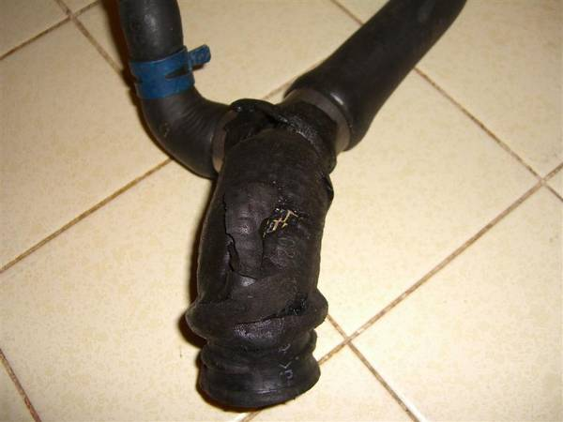
  - The seal between the main pump body and the distributor head can also leak. There's a how-to about replacing the distributor head seal that dieselgeek (aka corrado tdi) put together.

References and Links
- Bosch Replacement Parts and diagram for 0 460 404 985 - Distributor-type fuel-inj pump - VE4/10E2250R510-1.
- Thumbnail of the diagram above.
- How-to for hammer mod.
- How-to by dieselgeek for replacing the seal on the distributor head.
- How-to by Ray_g for re-assembling the pump head.
- Injection Pump seals from dieselgeek.
- Bosch seal kit from Impex.
- Special triangular socket for the security bolt from metalnerd.
- TDIClub Fuel Pump Leak sticky.
- Another TDIClub fuel pump leak fix how-to.

